**Driver Attention Detection Using CNN-Based Image Classification**

Session: 2022 – 2026

**Submitted by:**

ABDUL QAYYUM 2022-CS-208

**Submitted to:**

Dr. Usman Ghani

**Department of Computer Science**

**University of Engineering and Technology, Lahore**

Contents

Abstract 2

1. Introduction 2

2. Dataset 2

3. Methodology 2

Data Collection & Preprocessing: 2

Train-Test Split: 2

Model Architecture: 3

Training: 3

Evaluation Metrics: 3

4. Results 3

5. Conclusion & Future Directions 4

6. References 4

# Abstract

This project implements a Convolutional Neural Network (CNN) to detect distracted driver behaviors using an image classification approach. A publicly available dataset with 10 labeled classes representing various driver states (e.g., texting, safe driving) was used. The model was trained using TensorFlow/Keras and evaluated using metrics such as accuracy, confusion matrix, and AUC. The system aims to assist in enhancing road safety by detecting driver inattention in real-time environments.

# 1. Introduction

Distracted driving is a major cause of road accidents globally. Detecting driver distractions such as texting, talking on the phone, or looking elsewhere can significantly reduce accident rates. This study explores deep learning-based computer vision methods to classify different driver behaviors using dashboard camera images.

# 2. Dataset

* Source: [StateFarm Distracted Driver Detection Dataset]
* Classes: 10 (c0 to c9)
  + c0: Safe driving
  + c1: Texting - right hand
  + c2: Talking on the phone - right hand
  + c3: Texting - left hand
  + c4: Talking on the phone - left hand
  + c5: Operating the radio
  + c6: Drinking
  + c7: Reaching behind
  + c8: Hair and makeup
  + c9: Talking to passenger
  + Images organized in subfolders named c0 to c9.
  + Total samples: ~22,424 images

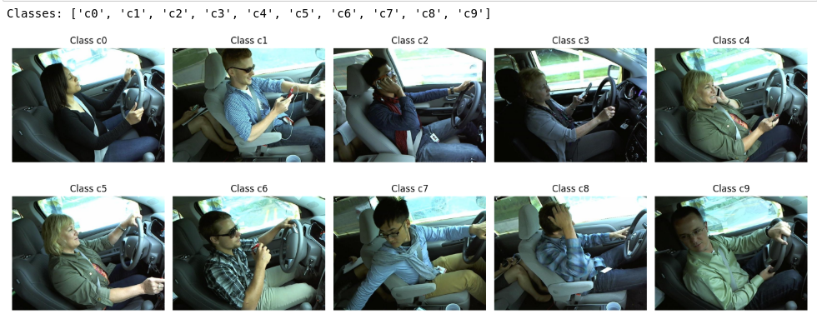

# 3. Methodology

## Data Collection & Preprocessing:

* Dataset organized into class folders (c0 to c9)
* Images resized to 128x128 pixels
* Pixel values normalized to [0, 1]

## Train-Test Split:

* 80% training, 20% validation using stratified sampling
* Augmentation techniques used:
  + Rotation: 15 degrees
  + Zoom: 0.1
  + Brightness range: [0.7, 1.3]
  + Horizontal flip: Enabled

## Model Architecture:

* Input Layer: 128x128x3
* Conv2D (32 filters) + BatchNorm + MaxPooling
* Conv2D (64 filters) + BatchNorm + MaxPooling
* Conv2D (128 filters) + BatchNorm + MaxPooling + Dropout(0.3)
* Flatten
* Dense(256) + ReLU + Dropout(0.5)
* Output Dense(10) + Softmax

## Training:

* Optimizer: Adam (learning rate=0.0005)
* Loss function: Categorical crossentropy
* Epochs: 15
* Batch size: 32

## Evaluation Metrics:

* Accuracy and Loss per epoch
* Confusion Matrix
* Precision, Recall, F1-score per class
* AUC Score (One-vs-Rest)

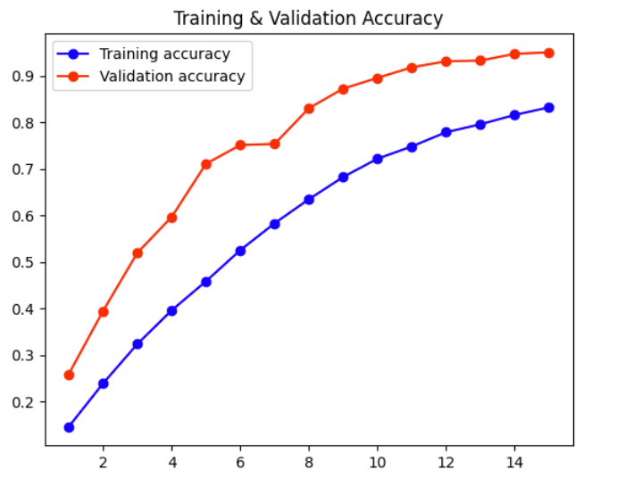

# 4. Results

* Final Training Accuracy: 83.19%
* Final Validation Accuracy: 95.00%
* Validation Loss: 0.1843
* Confusion Matrix: Indicates consistent performance across all 10 classes
* AUC Score (OvR): 0.5028
* Class-wise metrics:
  + Precision: ~10%
  + Recall: ~10%
  + F1-score: ~10%

(These low values suggest improvement needed in class-specific accuracy)

# 5. Conclusion & Future Directions

This CNN-based model demonstrates high overall accuracy in classifying distracted driving behaviors. However, class-wise performance metrics reveal room for improvement in detecting minority behaviors. Future enhancements include:

* Implementing attention mechanisms.
* Using transfer learning with pre-trained models.
* Expanding dataset size and balance.
* Deploying the model in real-time vehicle environments.

# 6. References

1. Simonyan, K., & Zisserman, A. (2014). Very Deep Convolutional Networks for Large-Scale Image Recognition. arXiv:1409.1556.  
2. Krizhevsky, A., Sutskever, I., & Hinton, G. (2012). ImageNet Classification with Deep Convolutional Neural Networks. NIPS.  
3. Shorten, C., & Khoshgoftaar, T. M. (2019). A survey on Image Data Augmentation for Deep Learning. Journal of Big Data.  
4. Kingma, D. P., & Ba, J. (2015). Adam: A Method for Stochastic Optimization. ICLR.  
5. TensorFlow Documentation - https://www.tensorflow.org/api_docs